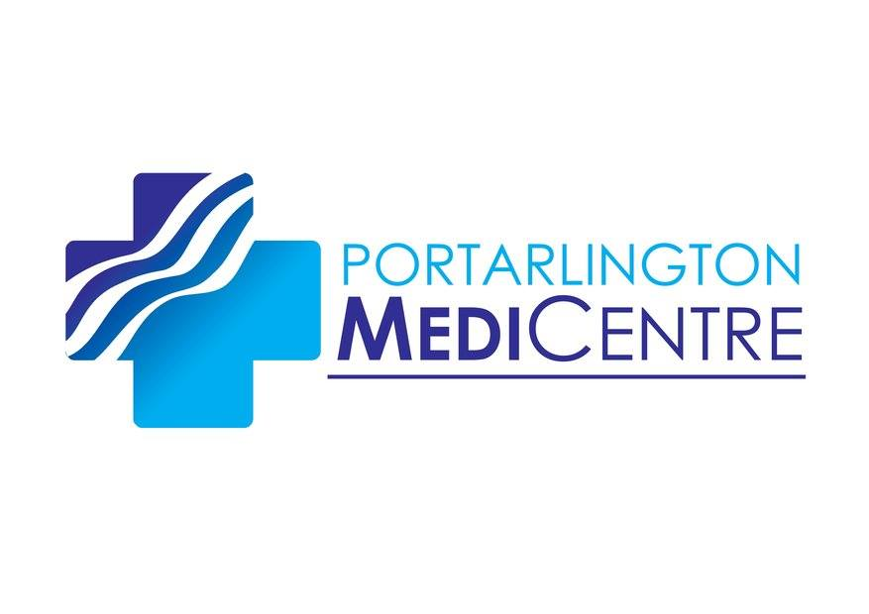

Patient consent for processing of health data.

To assist with your care we at The MediCentre need to collect personal data about you. This information will include details of your health and your treatments.

We may also need to record additional information that while may not seem to relate directly to your health it would help in our treatment of you. Examples of this kind of information would include things like your age, gender, marital status, number of children you have, your nationality, your employment status, religion, prison sentences. Our policy is only to collect and record information about you that helps in your treatment.

Declaration.

- I understand my health information will be seen or shared only with medical and administrative staff involved in my care or where The MediCentre is required to do so by law.
- I understand that for the purposes of my treatment administrative staff may have to access my health data. Reasons for this access would include the re-issuance of prescriptions, the opening of letters and recording of information from hospitals about me, downloading and saving in my file results from laboratories, typing of letters to hospitals and other similar health related issues.
- I understand that all The MediCentre staff sign a confidentiality agreement that binds them not to disclose my details to any unauthorised persons not involved in my care.
- I understand that any health data shared outside of the practice for the purposes of my health treatment will, normally, be limited to information related to a particular treatment and not my entire file.
- I understand that my health data will be stored primarily on a secure database operated by a specialist company called Clanwilliam Health and I understand that Clanwilliam Health are only allowed process my health data under The MediCentre’s instructions.
- I understand the law provides that in certain instances personal health information can be disclosed, e.g. in the case of some infectious diseases.
- I understand that The MedCentre will only release information to, for instance solicitors or insurance companies, at my express request.
- I understand that I can withdraw consent for processing of my personal health data at any time.

I *WRITE NAME HERE thereby freely consent for The MediCentre to process my personal data, include health information, for the purpose of my on-going health care treatment in accordance with what I understand above.

_______________________________________ _____________________
Signed Patient or Guardian Date of Birth

Today’s Date _____/____/________

